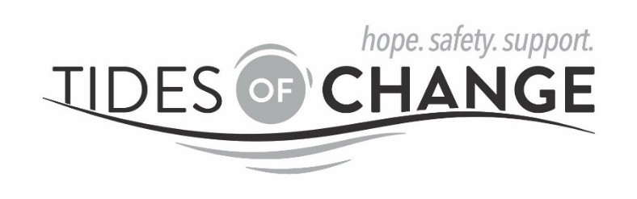

POSITION TITLE: Counselor
LOCATION: Tillamook, OR; Willing to consider a remote position
HOURS: Monday-Friday 9am-5pm; Flexible
(FTE) 1 FTE; Willing to consider .5FTE or 1 FTE
REPORTS TO: Executive Director
WAGE&BENEFITS: DOE and Licensure Status; Generous benefits package includes medical/dental/vision, PTO, retirement account benefits, Clinical Supervision, and professional development.

Tides of Change (ToC) is a private non-profit organization established in 1982, serving Tillamook County, Oregon, and is the primary community-based advocacy service for survivors of domestic/dating violence, sexual violence, stalking and trafficking. Our services include a 24-hour helpline, a confidential shelter, a drop-in advocacy center, counseling, and therapeutic art and support groups.

Position Summary: The Counselor will be stationed at ToC and will provide counseling services both individual and group to adult and youth survivors of domestic/dating violence, sexual violence, stalking and trafficking as well as child witnesses to IPV.

All persons of every race, ethnic background, spiritual belief, economic status, gender identity, sexual orientation, age or personal ability, are equally affirmed into membership, leadership and employment at Tides of Change and are welcomed and strongly encouraged to apply.

Primary Duties and Responsibilities:
- Provide counseling services including intakes and treatment planning for survivors of domestic/dating violence, sexual violence, stalking and trafficking as well as child witnesses to IPV
- Facilitate Intimate Partner Violence, TREM and Seeking Safety Support Groups
- Provide emergency crisis intervention services for survivors including but not limited to safety planning and information and referral and connection with ToC advocates and/or other community resources
- Advocate for victims with partnering agency systems to ensure high quality services to survivors
- Collect data for reporting and evaluation purposes
- Attend all grant required phone meetings, in-person meetings and trainings
- Participation in project evaluation.
- Advocate for victims with partnering agency systems to ensure high quality services to survivors
- Complete all required documentation

General Duties: (to be included on all job descriptions)
- Participate in various team projects including team meetings, coordination and implementation of pertinent activities, and other duties as necessary or assigned by supervisor
- Maintain reports and documentation consistent with ToC procedures and turn in all reports and documentation in a timely fashion
- Attend appropriate community meetings and participate in collaborative community projects
- Attend relevant trainings
- Contribute to creation of press releases and media materials for job-related projects
- Make necessary referrals to general ToC advocates, and maintain inter-agency communication

Qualifications and Skills-Required:
- An understanding of domestic violence, sexual assault, and oppression
- A Master’s degree in counseling or social work
- Ability to work with diverse groups of people including all ages, races, backgrounds, religions, etc.
- Proficient computer skills as necessary to meet program objectives
- Reliable vehicle, current driver’s license and proof of insurance
- Strong organizational and recordkeeping skills
- Ability to work flexible hours and be self-motivated
- Demonstrated ability to provide empathetic direct services and advocacy for survivors
- Strong communication and collaboration skills

Qualifications and Skills-Preferred:

- Bilingual in English/Spanish preferred
- Knowledge of community health and social service programs
- Have demonstrated program planning skills
- Previous completion of a 40-hour Domestic and Sexual Violence Advocacy Training.

To Apply:
- Send your resume and cover letter to valerie@tidesofchangenw.org
- Please highlight any experience that specifically addresses the essential functions of this position
- Incomplete applications will not be considered.

